Code Review: I2308081
Reviewer: Mark Dell
Date: September 15th, 2023

Bugs

Preventative Action/Safety

Design/Architecture (Duplication, appropriate project, namespaces, maintainability)

Data Model (Naming, good design, needs index?)

Performance (Minimize DB hits, excessive loops, queries, scalable)

UI (Alignment, naming, standardization, tab order)

Error Handling (Behind events, appropriate parameter checking)

Cleanup (Dispose code, remove handlers, large data objects)

Readability (Well-named variables, methods, clear algorithm, is it understandable)
- While I realize that this was copied from Sales Order code, there is no benefit to wrapping this property/method in a local private method (plus the use of the if statement is redundant). We should try to not create or copy un-useful code like this. Please, remove it and reference the “MultiDivision” property/method itself in the one location this is used.
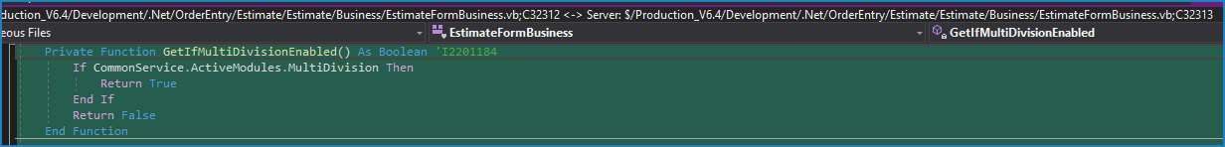

Comments (Useful, explains why rather than how)
- Your code comment for this method mentions “UNION” but there is no UNION in this SQL. If the UNION is in the caller, or is in a stored view that is used, please modify the comment to clarify this, otherwise correct this to eliminate the confusion from the use of the wrong term. Also, I am unsure if the wrong column was used for the Sell flag or not, as you said “hardcode Sell to 1”, but it is instead returning the Items’ Sell flag. Please clarify that as well.
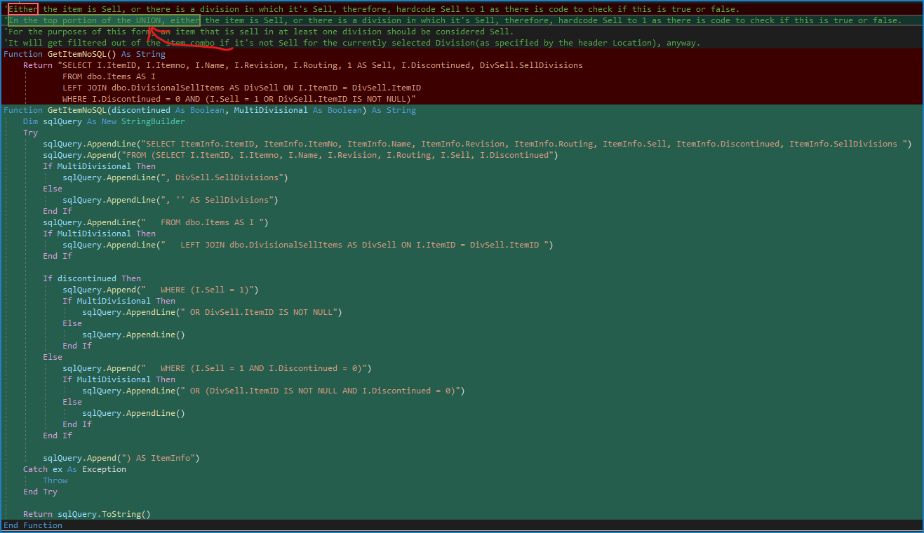

Message Boxes (Grammar, spelling, captions, appropriate icons)

Ticket Management (Release Branch?, Testing Notes)

Extras

